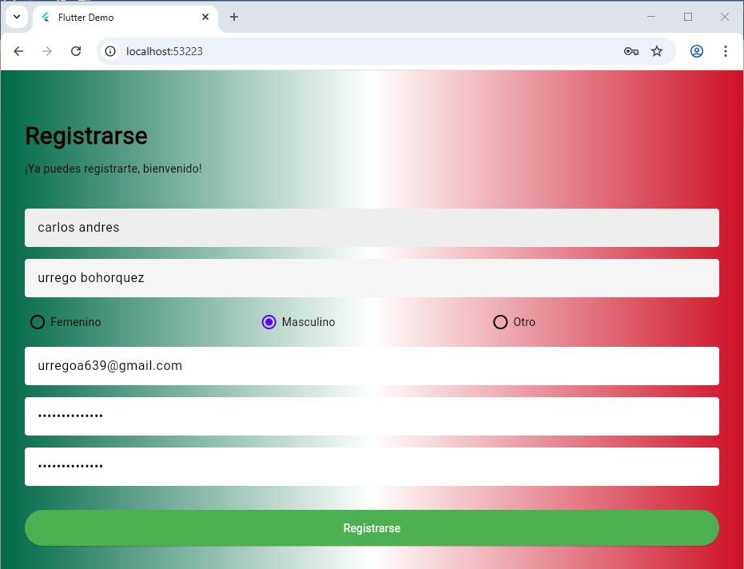

Código
import 'package:flutter/material.dart';

void main() {
runApp(const MyApp());
}

class MyApp extends StatelessWidget {
const MyApp({super.key});

// This widget is the root of your application.
@override
Widget build(BuildContext context) {
return MaterialApp(
title: 'Flutter Demo',
theme: ThemeData(
primarySwatch: Colors.blue,
fontFamily: 'Raleway',
colorScheme: const ColorScheme.light(),
scaffoldBackgroundColor: const Color(0xFF87CEEB), // Sky blue for beach theme
inputDecorationTheme: const InputDecorationTheme(
fillColor: Colors.white,
filled: true,
)),
debugShowCheckedModeBanner: false,
home: const RegisterPage(title: 'Flutter Demo Home Page'),
);
}
}

enum SigninCharacter { femenino, masculino, otro }

class RegisterPage extends StatefulWidget {
const RegisterPage({super.key, required this.title});
final String title;

@override
State<RegisterPage> createState() => _RegisterPageState();
}

class _RegisterPageState extends State<RegisterPage> {
SigninCharacter? _sex = SigninCharacter.femenino;

String _nombre = '';
final _formKey = GlobalKey<FormState>();
String _password = '';

@override
Widget build(BuildContext context) {
return Scaffold(
body: Container(
decoration: const BoxDecoration(
gradient: LinearGradient(
colors: [Color(0xFF006847), Color(0xFFFFFFFF), Color(0xFFCE1126)], // Mexican flag gradient: green, white, red
begin: Alignment.centerLeft,
end: Alignment.centerRight,
),
),
child: SingleChildScrollView(
child: Container(
margin: const EdgeInsets.only(top: 40, left: 30, right: 30),
child: Column(
crossAxisAlignment: CrossAxisAlignment.start,
children: <Widget>[
Container(
margin: const EdgeInsets.only(top: 20),
child: const Text(
'Registrarse',
style: TextStyle(fontWeight: FontWeight.bold, fontSize: 30, color: Colors.black),
),
),
const Padding(
padding: EdgeInsets.symmetric(vertical: 10),
child: Text('¡Ya puedes registrarte, bienvenido!', style: TextStyle(color: Colors.black)),
),
Form(
key: _formKey,
child: Column(
children: <Widget>[
Padding(
padding: const EdgeInsets.only(top: 30),
child: TextFormField(
decoration: InputDecoration(
hintText: 'Nombre',
hintStyle:
const TextStyle(fontWeight: FontWeight.w600),
fillColor: Colors.grey.shade200,
focusedBorder: const OutlineInputBorder(
borderSide: BorderSide(
width: 0, style: BorderStyle.none),
),
enabledBorder: const OutlineInputBorder(
borderSide: BorderSide(
width: 0, style: BorderStyle.none),
),
filled: true),
validator: (value) {
if (value!.isEmpty) {
return 'Por favor ingrese su nombre';
} else if (value.length < 6 || value.length > 20) {
return 'El nombre debe tener entre 6 y 20 caracteres';
}
return null;
},
onSaved: (value) {
setState(() {
_nombre = value.toString();
});
},
)),
Padding(
padding: const EdgeInsets.only(top: 15),
child: TextFormField(
decoration: InputDecoration(
hintText: 'Apellidos',
hintStyle:
const TextStyle(fontWeight: FontWeight.w600),
focusedBorder: const OutlineInputBorder(
borderSide: BorderSide(
width: 0, style: BorderStyle.none),
),
enabledBorder: const OutlineInputBorder(
borderSide: BorderSide(
width: 0, style: BorderStyle.none),
),
filled: true),
validator: (value) {
if (value == null || value.isEmpty) {
return 'Por favor digite su apellido';
} else if (value.length < 6 || value.length > 20) {
return 'El apellido debe tener entre 6 y 20 caracteres';
}
return null;
},
)),
Padding(
padding: const EdgeInsets.only(top: 15),
child: Row(
children: <Widget>[
Expanded(
child: Row(
children: [
Radio<SigninCharacter>(
value: SigninCharacter.femenino,
groupValue: _sex,
onChanged: (SigninCharacter? value) {
setState(() {
_sex = value;
});
},
),
const Text('Femenino', style: TextStyle(color: Colors.black))
],
),
),
Expanded(
child: Row(
children: [
Radio<SigninCharacter>(
value: SigninCharacter.masculino,
groupValue: _sex,
onChanged: (SigninCharacter? value) {
setState(() {
_sex = value;
});
},
),
const Text('Masculino', style: TextStyle(color: Colors.black))
],
),
),
Expanded(
child: Row(
children: [
Radio<SigninCharacter>(
value: SigninCharacter.otro,
groupValue: _sex,
onChanged: (SigninCharacter? value) {
setState(() {
_sex = value;
});
},
),
const Text('Otro', style: TextStyle(color: Colors.black))
],
),
),
],
)),
Padding(
padding: const EdgeInsets.only(top: 15),
child: TextFormField(
decoration: InputDecoration(
hintText: 'Correo',
hintStyle:
const TextStyle(fontWeight: FontWeight.w600),
focusedBorder: const OutlineInputBorder(
borderSide: BorderSide(
width: 0, style: BorderStyle.none),
),
enabledBorder: const OutlineInputBorder(
borderSide: BorderSide(
width: 0, style: BorderStyle.none),
),
filled: true),
validator: (value) {
if (value!.isEmpty) {
return "El correo es necesario";
} else if (!value.contains('@')) {
return "El correo debe contener @";
} else {
return null;
}
},
)),
Padding(
padding: const EdgeInsets.only(top: 15),
child: TextFormField(
obscureText: true,
onChanged: (value) {
setState(() {
_password = value;
});
},
decoration: InputDecoration(
hintText: 'Contraseña',
hintStyle:
const TextStyle(fontWeight: FontWeight.w600),
focusedBorder: const OutlineInputBorder(
borderSide: BorderSide(
width: 0, style: BorderStyle.none),
),
enabledBorder: const OutlineInputBorder(
borderSide: BorderSide(
width: 0, style: BorderStyle.none),
),
filled: true),
validator: (value) {
if (value!.isEmpty) {
return "La contraseña es necesaria";
} else if (value.length < 10 || value.length > 20) {
return "La contraseña debe tener entre 10 y 20 caracteres";
} else {
return null;
}
},
)),
Padding(
padding: const EdgeInsets.only(top: 15),
child: TextFormField(
obscureText: true,
decoration: InputDecoration(
hintText: 'Confirmar contraseña',
hintStyle:
const TextStyle(fontWeight: FontWeight.w600),
focusedBorder: const OutlineInputBorder(
borderSide: BorderSide(
width: 0, style: BorderStyle.none),
),
enabledBorder: const OutlineInputBorder(
borderSide: BorderSide(
width: 0, style: BorderStyle.none),
),
filled: true),
validator: (value) {
if (value == null || value.isEmpty) {
return 'Por favor confirme su contraseña';
} else if (value.length < 10 || value.length > 20) {
return 'La contraseña debe tener entre 10 y 20 caracteres';
}
if (value != _password) {
return 'Las contraseñas no coinciden';
}
return null;
},
)),
Padding(
padding: const EdgeInsets.symmetric(vertical: 30),
child: SizedBox(
width: double.infinity,
height: 45,
child: ElevatedButton(
onPressed: () {
if (_formKey.currentState!.validate()) {
ScaffoldMessenger.of(context)
.showSnackBar(SnackBar(
content: Row(
mainAxisAlignment:
MainAxisAlignment.start,
children: const <Widget>[
Icon(
Icons.check_circle,
color: Color.fromARGB(
255, 255, 255, 255),
),
SizedBox(
width: 5,
),
Text(
"Usuario registrado correctamente",
style: TextStyle(
color: Color.fromARGB(
255, 255, 255, 255)),
)
],
),
duration:
const Duration(milliseconds: 2000),
width: 300,
padding: const EdgeInsets.symmetric(
horizontal: 8.0, vertical: 10),
behavior: SnackBarBehavior.floating,
shape: RoundedRectangleBorder(
borderRadius: BorderRadius.circular(3.0),
),
backgroundColor:
const Color.fromARGB(255, 12, 195, 106),
));
}
},
style: ElevatedButton.styleFrom(
backgroundColor:
Colors.green, // background (button) color
foregroundColor:
Colors.white, // foreground (text) color
),
child: const Text('Registrarse')),
)),
],
))
],
),
),
),
));
}
}

